1. Find a student average mark given mark1 and mark2.

Algorithms :-

Ans :-

STEP 1 :- start .

STEP 2 :- Declare variable mark1, mark2, avg.

STEP 3 :- Read values mark1, mark2.

STEP 4 :- Add mark1 and mark2 then divide it by 2 then assign the value to avg.

avg 🡨(mark1+mark2)/2

STEP 5 :- Display avg.

STEP 6 :- Stop.

Flow chart :-

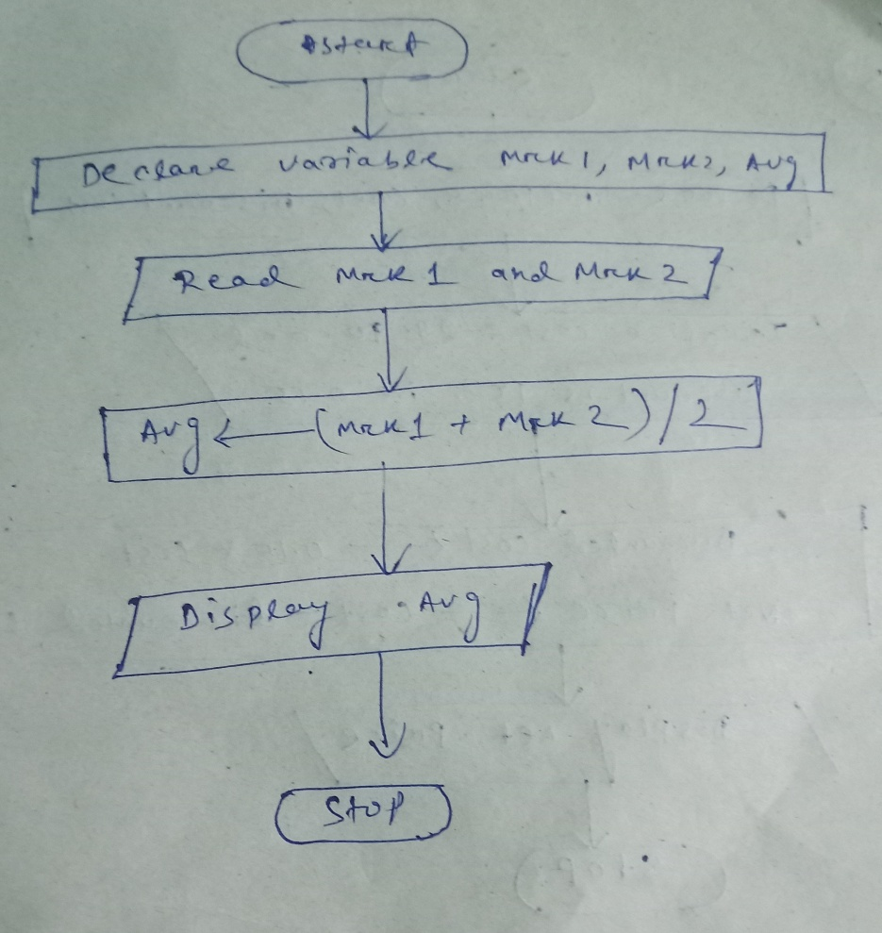

2. Calculate the total fine charged by library for late-return books. The charge is 0.20 INR for 1 day.

Algorithms :-

Ans :-

STEP 1 :- start .

STEP 2 :- Declare variable dt of rtn, lst dt for rtn, total fine, extended .

STEP 3 :- Read values dt of rtn, lst dt for rtn, chrg for 1day = 0.20.

STEP 4 :- substract last dt for rtn from date of rtn and assign value to extended day.

Extended day 🡨 dt of rtn – last dt for rtn.

STEP 5 :- multiply extended day with chrg for 1day then assign the value to total fine.

total fine 🡨extended day \* 0.20.

STEP 6 :- Display total fine.

STEP 7 :- Stop.

Flow chart :-

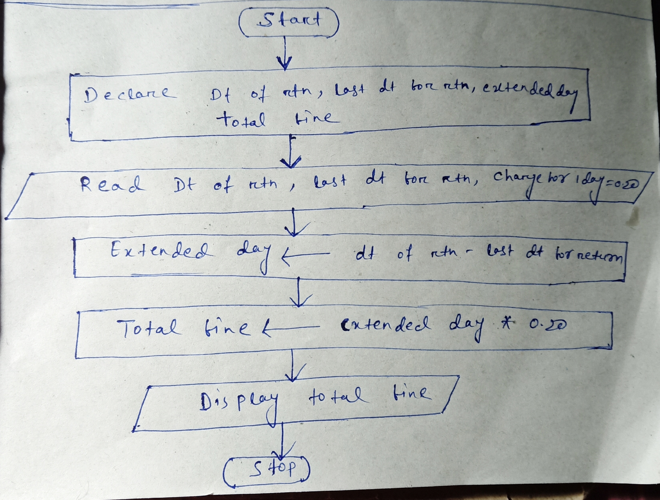

1. You had bought a nice shirt which cost Rs.29.90 with 15% discount. Count the nett price for the shirt.

Algorithms :-

Ans :-

STEP 1 :- start .

STEP 2 :- Declare variable net price, cost, discount cost .

STEP 3 :- Initialize cost =29.90 and discount is 15% i.e 0.15 .

STEP 4 :- multiply cost with discount and assign the value to discount cost.

Discount cost 🡨 0.15 \* cost.

STEP 5 :- substract discount cost from cost and assign value to nett price

Nett price🡨cost – discount cost.

STEP 6 :- Display nett price.

STEP 7 :- Stop.

Flow chart :-

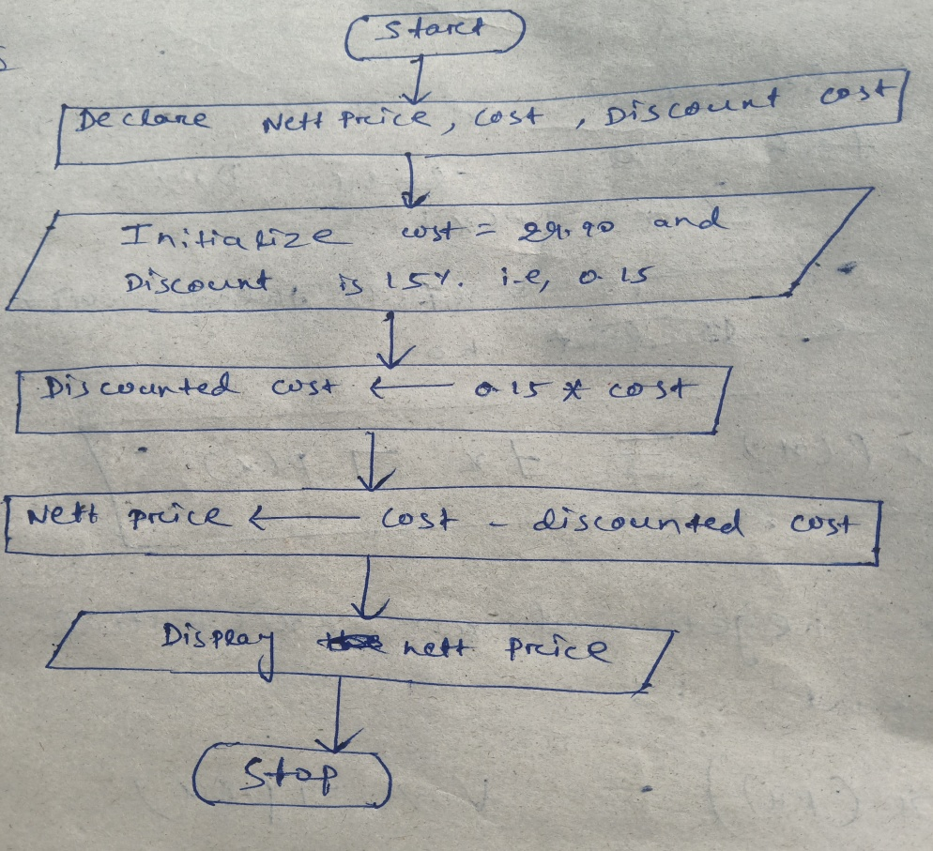

1. Find the smallest number among three different numbers.

Algorithms :-

Ans :-

STEP 1 :- start .

STEP 2 :- Declare variable a,b and c.

STEP 3 :- Read values a,b and c.

STEP 4 :- if a is less than b and c.

Display a is the smallest no.

Else if b is less than a and c.

Display b is the smallest no.

Else Display c is the smallest no.

STEP 6 :- Stop.

Flow chart :-

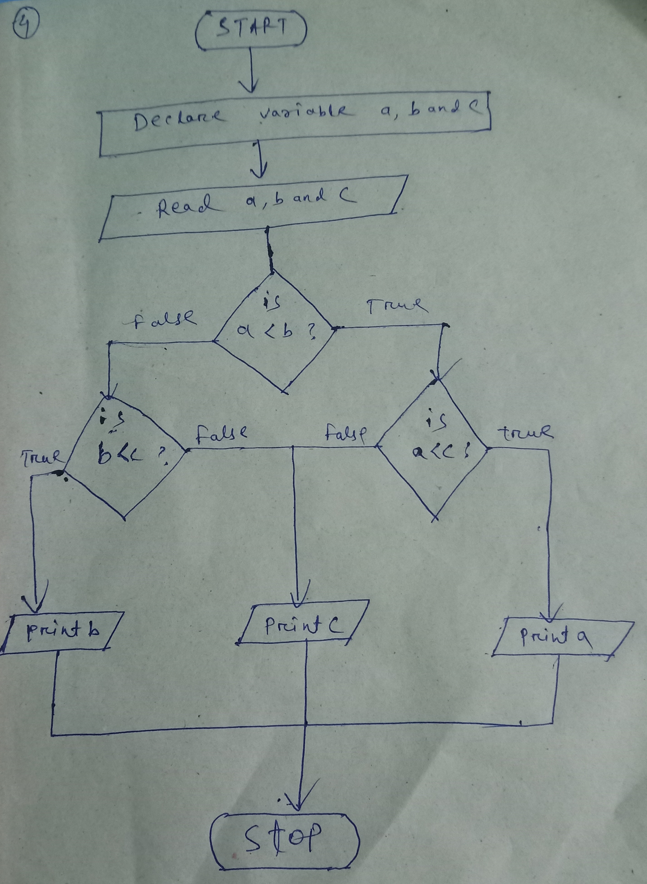

5. Find the Roots of a quadratic equation ax2 + bx + c = 0

Algorithms :-

Ans :-

STEP 1 :- start .

STEP 2 :- Declare variable root,D,a,b,c.

STEP 3 :- Read values a,b and c.

STEP 4 :-substract product of 4,a and c from sqr of b and assign value to D D 🡨 b\*b - 4ac.

STEP 5 :- if D is less than zero

Display roots are imaginary.

Else root is either addition of sqr root of D with –b then divide it with 2a

Or root is substract sqr root of D from –b then divide it with 2a.

root🡨 -b + sqr root of D/2a

or root🡨-b - sqr root of D/2a

STEP 6 :- display root

STEP 7 :- Stop.

Flow chart :-

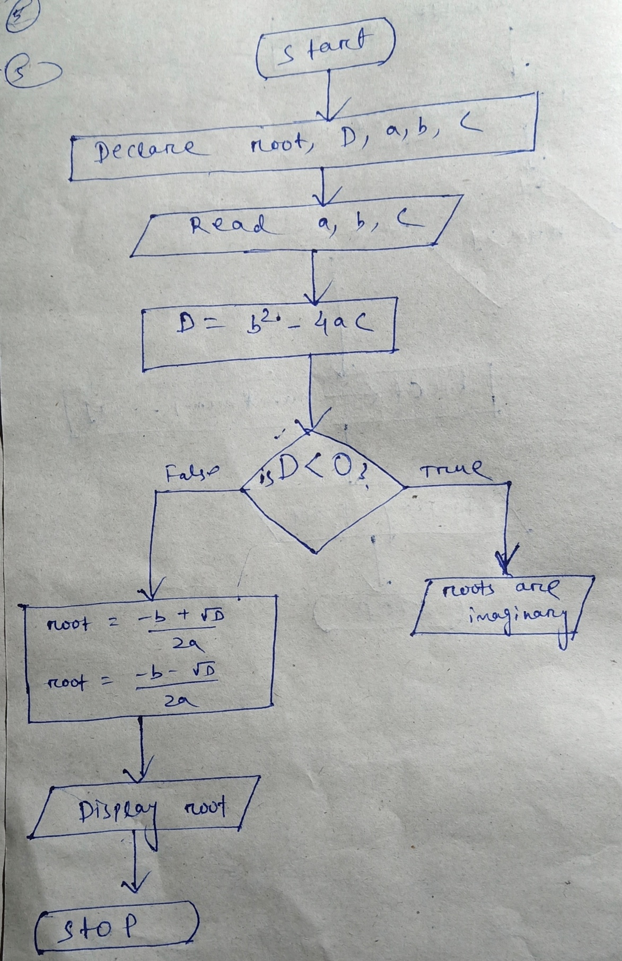

6. Find the factorial of a given number

Algorithms :-

Ans :-

STEP 1 :- start .

STEP 2 :- Declare variable num,fact.

STEP 3 :- Read values of num.

STEP 4 :- if num is greater than 1 then from value num upto 1 multiply each digit and store at fact.

fact 🡨num\*(num-1)\*(num-2) ….. \*1.

STEP 5 :- Display fact.

STEP 6 :- Stop.

Flow chart :-

